Converting a large number to different formats

|  |  |
| --- | --- |
| **Number size:** | capability of accepting any large number but our test will be limited to maximum 16k digits |
| **Input formats:** | Decimal, Binary, ZOT, WZOT |
| **Objectives:** | Designing efficient functions (**running time**), for LUT4A and LUT4A **(Memory)**  **And evaluation of the functions** |
| **Converting direction:** | Right to Left |
| **Functions:** | In the first steps **Blue** ones should be provided |
| **Dec2Bin** | Format decimal to binary |
| **Bin2Dec** | Format binary to decimal |
| **Dec2A** | Format decimal to A |
| **A2Dec** | Format A to decimal |
| **Bin2A** | Format binary to A |
| **A2Bin** | Format A to Binary |
| **A2B** | Format A to B |
| **B2A** | Format B to A |
| **Bin2B** | Format binary to B |
| **B2Bin** | Format B to binary |
| **Dec2B** | Format decimal 2 B |
| **B2Dec** | Format B to Decimal |
| **BinRNG** | Binary random generator (For example: [Mersenne twister](https://en.wikipedia.org/wiki/Mersenne_twister))  https://en.wikipedia.org/wiki/List_of_random_number_generators |
| **DecRNG** | Decimal Random Generator |
| **LUT4A** | 1 dimensional LUT for a number presented in format A |
| **LUT4B** | 2 dimensional LUT for a number presented in format B |
| **ContesterDEC2B** | Conversion tester for a number presented in decimal to format B |
| **ContesterBin2B** | Conversion tester for a number presented in binary to format B |
| **Runtime** | Measuring the average running of each function |
| **NZ Digit counters** | Non-zero digit counter |
|  |  |

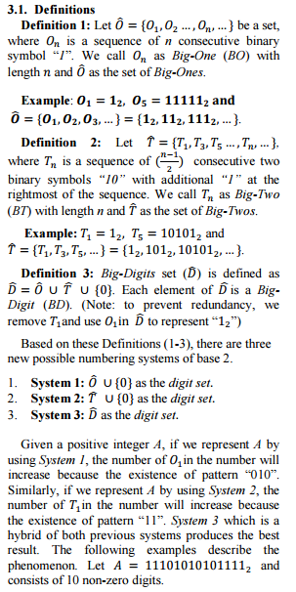

Bint2A(**binary random number** as binary, **window** as integer, **mode** as integer, C as binary)

Window: the maximum size of digits in Format A

**Mode:**

Mode=0 Output has just O , Mode =1 Output has just T , Mode 2 Output has both O and T

**C:**

C=0 No Compression, C=1 with compression

Example for Format A (window is 4): if A= 11111100010100001010101000001 then

Mode 0: A= O2000O4000O10O10000O10O10O10O100000O1

A=O2Z3O4Z3O1Z1O1Z4O1Z1O1Z1O1Z1O1Z5O1

Mode1: A=T1T1T1T1T1T100000T3000000T3000T300000T1

A= T1T1T1T1T1T1Z5T3Z6T3Z3T3Z5T1

Mode 3: A= O2000O40000OT300000T3000T300000O1

A= O2Z3O4Z4OT3Z5T3Z3T3Z5O1